- Login ke Supabase
- Buat project baru (simpan passwordnya)
- Klik Connect
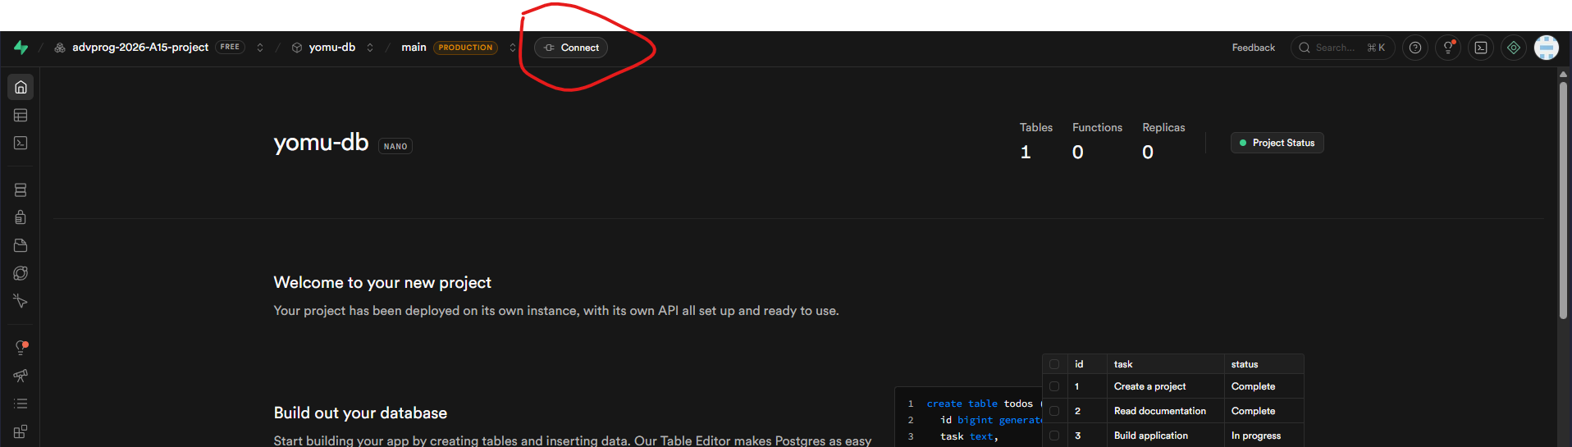
- Type: JDBC, method: session pooler
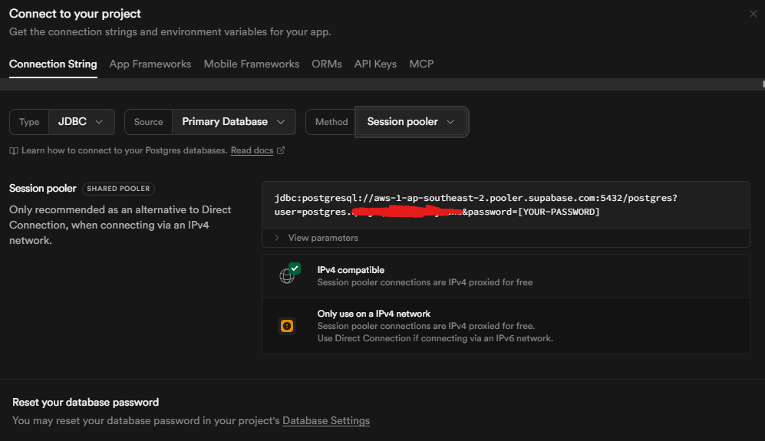
- Copy URL nya, taro di application.properties bagian spring.datasource.url, modif belakangnya pakai /postgres?sslmode=require
Ex:
spring.datasource.url=jdbc:postgresql://aws-1-ap-southeast-2.pooler.supabase.com:5432/postgres?sslmode=require
- User ditaro di spring.datasource.username
Ex:
spring.datasource.username=postgres.xxxxxxxxxxxxxxxxxxxx
- spring.datasource.password=[PASSWORD PROJECT KALIAN]

